SLAYING GIANTS – COURAGE DOES WHAT’S RIGHT
Welcoming Question: Who is the bravest person you know?

Chat through the story of David & Goliath
ASK: It may have been scary for David to fight Goliath, but he knew God was with him, so he did it. Think of something you know you need to do, but you’re worried, nervous, or afraid to do it.
DO: Write down what you may feel nervous, worried or afraid to do inside the bowling pin.

Write down some things that will help you conquer some fears next to the bowling pin in the white section of the page.

- What do you think helped David stand up to a giant?

GOD GIVES YOU COURAGE TO DO WHAT’S RIGHT!
Courage = fearlessness / spunk / grit / daring

Memory Verse: Be on guard. Stand firm in the faith. Be courageous. Be strong – 1 Corinthians 16:13

Action Step: What do you think will give you the courage to do what’s right, even when no one else is doing it?

Pray Together:
God, Thank You for filling us with your courage to do the right thing even when no one else is.
In Jesus’ name, amen.

Fun Activity:

What comes next? – Pre school - 2

David & Goliath Maze – Grade 3 - 5

Make own sling shot: https://youtu.be/iYlJirFtYaA

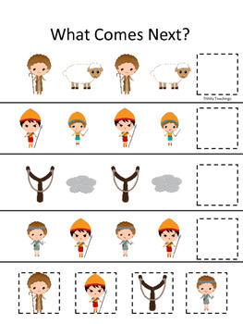
Age Group – Pre school – Grade 2

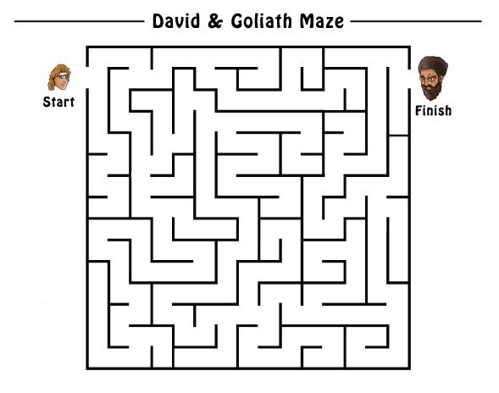
Age Group – Grade 3 - 5

